INCOME STATEMENT: reporting a company's financial performance over a specific accounting period
Important part of the company performance report
Other names: profit and loss statement | the statement of revenue and expense

Perpetual inventory system | Periodic
Suitable for organizations with small number of inventories that are expensive  Ex- car sales  Purchase  - Every purchase are recorded to inventory  inventory ---- ----- debit  Cash --------------------credit  - Purchase return  Cash ------------------ debit  Inventory ----------------credit  Sales  When sale occurs it is directly recorded to the cost of goods sold  Cash------------------debit  Sales ------------------credit  Cgs = bi + purchase + ei  CGS------------------debit  Inventory----------------credit  - At the end of the accounting period  NO ENTRY | Suitable for organizations with large number of inventory that are hard to count on the go.  Purchase  - Purchase is recorded to purchase  Purchase ---- ----- debit  Cash --------------------credit  - Purchase return  Cash ------------------ debit  Purchase return ----------------credit  And allowance  - Purchase discount  Cash---------------debit  Purchase discount---credit  Sales  When sales occurs it is recorded to sales  Cash---------------------debit  Sales----------------------credit  At the end of the period  CGS = BI + purchase + EI  - At the end of the accounting period  Ending inventory ....... 2,400  CGS ......................... 3,600  purchase ………… .... 5,400  BI ............................... 600

FOB shipping point or FOB origin | FOB Destination
Buyer takes all the risk when the inventory leaves salers dock | Saler takes all the risk until it reaches  Buyer.

Operating Revenue
Definition –
Revenue realized through primary activities
Example –
Revenue from primary activities refers to the revenue or fees earned in exchange for offering those services.

Revenue

Non-operating Revenue
Definition-
Revenue realized through secondary, non-core business.
Examples-
- Income from interest earned on business capital parked in the bank.
- Rental income from business property
- Income from strategic partnerships like royalty payment receipts.
- Income from an advertisement display placed on business property.

Gains

Also called other income.

gains indicate the net money made from other activities,

Example:

like the sale of long-term assets.

net income realized from one-time non-business activities,

such as a company selling its old transportation van,

unused land,

selling a subsidiary company.

Operating Expense
Definition –
All expenses incurred for earning the normal operating revenue
Linked to the primary activity of the business.
Example:
- Cost of goods sold (COGS).
- Selling, general and administrative expenses (SG&A);
- aaaaaaaa
- Depreciation or Amortization.
- Research and development (R&D) expenses.
- Typical items that make up the list are
- Employee wages, - sales commissions,
- Expenses for utilities
- Electricity.
- Transportation.

Expense

Non-operating Expense
Definition-

COGS shows the expenses incurred in producing the goods over a certain period of time. The formula for COGS is:
Does not include indirect expenses such as sales force costs and distribution costs (shipping cost)
Other operating expenses | overhead expenses | (SG&A) Selling, general, and administrative
Definition: is the amount which generally does not depend on sales or production quantities. These include
- marketing expenses
- rent and utilities
- payroll
- office expense
- operating leases
- IT (software services)
- other fixed costs
- raw materials
- Maintenance expenses.

Capital expenditures include costs related to acquiring or upgrading tangible and intangible assets.
Tangible business assets real estate, factory equipment, computers, office furniture, and other physical capital assets.
Tangible Assets i intellectual property, copyrights, patents, trademarks, et. al.

NB:
Accountants sometimes remove non-operating expenses to examine the performance of the business, ignoring the effects of financing and other irrelevant issues.
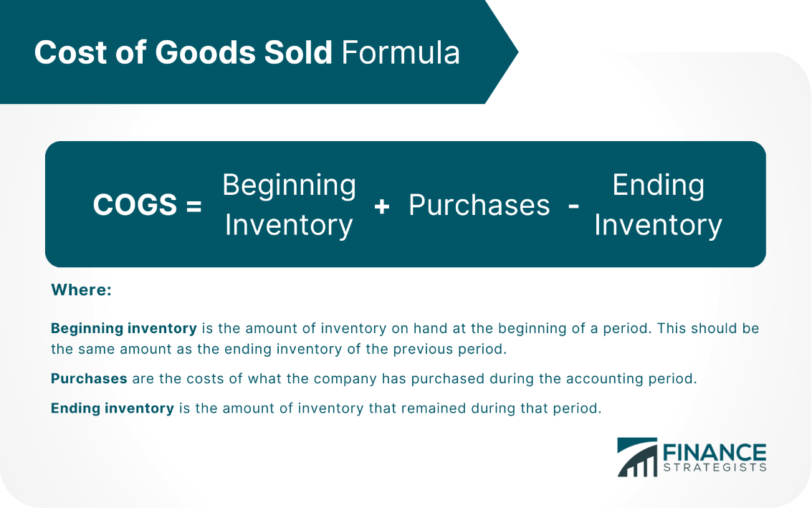

Deferrals and Accruals

Accrual is incurring expenses and earning revenue without paying or receiving cash.
Deferral of revenue leads to creating a liability as it is in most cases treated as unearned revenue.
Deferral of income refers to the spread of revenue over time. The same is the case with expenses as well.

A fixed asset register is a document/register which maintains a list of all fixed assets
Question #10 – Explain the difference between working capital and available cash/bank balance.
Working capital is the day-to-day funds requirement for any business. Cash and bank balance are a part of any organization’s total working capital availability. However, working capital is more than just cash and bank balances. Current assets and liabilities also make up for the business’s working capital.

Let us assume that $ 5000 is receivable from a debtor on 1-Apr-17, and $ 4000 is also payable to a creditor on the same day.
working capital = Current Assets – Current Liabilities

List of Current Assets
It includes the following –
- Cash and Cash Equivalents
- Marketable Securities
- Account Receivables
- Inventory/Stock
- Prepaid Expenses
- Non-Trade Receivables
- Other Current Assets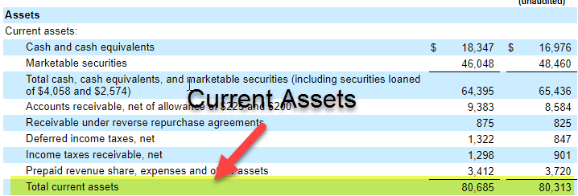

#4 – Inventory
Inventory means the goods and the material that is in stock. There are three Types of Inventory – Raw material inventory, work in progress inventory, and finished goods inventory.
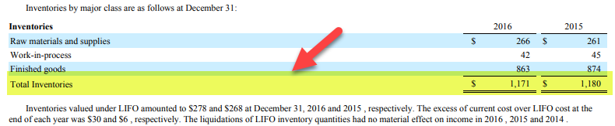

DEPRECIATION
Accounting Treatment of Depreciation
When purchasing the asset
The cost will be recorded including the following
COST: =
(-) = Trade discount
(+) = nonrefundable taxes (VAT is Refundable)
(+) = direct attributable costs
- cost for site preparation.
- Initial delivery and handling costs.
- professional fees, engineer hired to install machinery
- staff cost arising directly from the construction or acquisitions of the asset
- testing cost after deducting after deducting the net proceeds after selling sample products that are produced while testing.
(+) = dismantling cost( when useful life ends to dismantle the asset)
When to start charging depreciation
- When asset is ready to use
Without Accumulated Depreciation | With Accumulated Depreciation
Recording depreciation:  Dep acct---------------dr  Asset acct ----------------cr  Since all expenses in income account are going to be closed with profit and loss account then dep exp will be closed with profit and loss account  Profit and loss ------- dr  Dep acct ------------------cr  On income statement  Income statement  Dr Cr  Depreciation exp  On Balance Sheet  Dr Cr  Asset  Dep exp ( of the year) | Recording depreciation:  Dep acct --------------- dr  Accumulated dep ------- cr  Profit and loss -------- dr  Dep acct ------------------- cr  On income statement  Income statement  On Balance Sheet  Dr Cr  Asset ------ original cost  Accum dep (yr * dep)- xxx (BOOK VALUE)  NB: at the end of the assets useful life  Accumulated dep will be reversed  Accum dep -------- cr  Asset ----------------cr

A nominal account is a general ledger account that you close at the end of each accounting year. Basically, you store accounting transactions in a nominal account for one fiscal year. At the end of the fiscal year, you transfer the balances in the account to a permanent account.

Accruals and deferrals
Accruals  A charge for work that has been done but not yet invoiced.  Means Recognition of revenue and costs as they are earned or incurred not  When cash is received or paid. | Deferrals  A postponement of an action or event.
Example : we performed 5000 worth of service for a customer on account  A/R ---------------------- 5000  Service revenue --------5000 | Example: we received a cash advance of 5000 from a customer.  Cash -------------------------- 5000  Unearned service revenue --- 5000  When we earn it ( suppose half of it)  Unearned service revenue – 2500  Sales revenue -----------------2500  Example 2: prepay rent for 3 months in advance rent is 1000 per month  When it occurs:  Prepaid rent ------- 3000  Cash ---------------------3000  At the end of the month  Rent expense -----------1000  Prepaid rent --------------1000
- Cash after  - Receivables (revenues)  - Payable ( expense) | - Cash before  - Prepaid (asset)  - Unearned revenue (liability)

Hard Journal entries
1 | Outstanding salary of 20,000  (if you didn’t pay salary for the month you still have to record it) | Salary act( salary exp) --------------------- 20,000 (expense)  Outstanding salary (salary payable ---- 20,000 (liability)
2
3
4
5
6
7
8
9
10

